BIT4138: ADVANCED SECURITY AND CRYPTOGRAPHY
Student details
Student Name: Wendy Jane
Admission Number: BSCCS/35574/2024
Course: Computer Science
Unit Code: BIT4138
Unit Name: Advanced Security and Cryptography
Lecturer Name: Mr. Michael Nyoro
Semester/Academic Year: 2025/2026
Project details
Selected Technologies: Python, cryptii
GitHub link
https://github.com/wjane8346/BIT4138-Week1

Contents
WEEK ONE: Compare Caesar Cipher and Vigenère Cipher 4
Python Installation 4
Caesar Cipher Output 5
Online Caesar Cipher Test 5
Vigenère Cipher Test 6
Caeser cipher Decryption Demonstration 6
Vigenère Cipher Decryption Demonstration 6
WEEK TWO: Stream Cipher and pseudo randomness 7
Practical demonstrations 7
D1: Python Random Numbers 7
D2: Linear Congruential Generator (LCG) 7
D3: XOR Stream Cipher 8
D4: One-Time Pad (OTP) Simulation 8
ASSIGNMENT 1: Pseudorandom Sequence Generator 9
Advanced practice tasks 9
Task 1: XOR cipher 9
Task 2: Menu-driven cipher stream 10
WEEK THREE: Period, Linear complexity and randomness testing 10
Practical demonstrations 10
D1: Generate binary random sequences 10
11
CLASS ACTIVIITIES 13
Activity 1: Finding Sequence Period 13
Activity 2: Randomness Observation 13
ASSIGNMENT 1: Randomness Testing Program 14
WEEK 4: SREAM CIPHER CRYPTANALYSIS 15
Generate LFSR Sequences 15
Detect Repetition in LFSR 16
Observe Predictability 16
Analyze Weak Patterns 17
ASSIGNMENT 1: LFSR Generator with Period Detection 17
WEEK 5: BLOCK CIPHERS FEISTEL STRUCTURES 18
Practical demonstrations 18
D1: Divide plaintext into blocks 18
D2: Apply permutations 19
D3: Simulate Substitutions 19
D4: Perform Feistel Rounds 20
D5: Observe Avalanche Effect 20

WEEK ONE: Compare Caesar Cipher and Vigenère Cipher

Python Installation
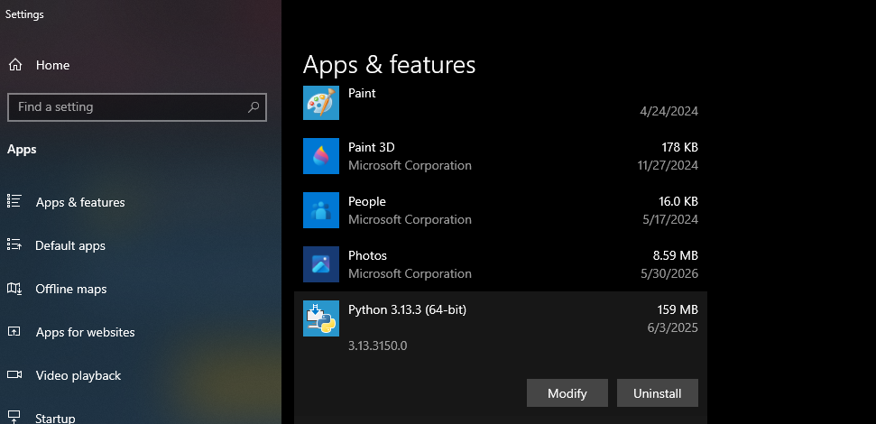
Figure 1: Installation of Python 3 for cryptography practical activities for these tasks of advanced cryptography.

Caesar Cipher Output
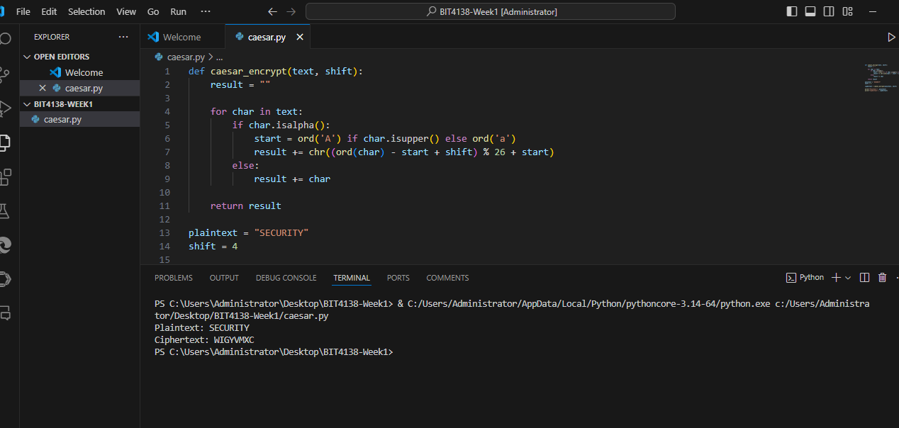
Figure 2: Creation and implementation of the Caesar Cipher encryption program using Python in Visual Studio Code. Successful execution of the Caesar Cipher program showing the encryption of the plaintext “SECURITY” using a shift value of 4.

Online Caesar Cipher Test
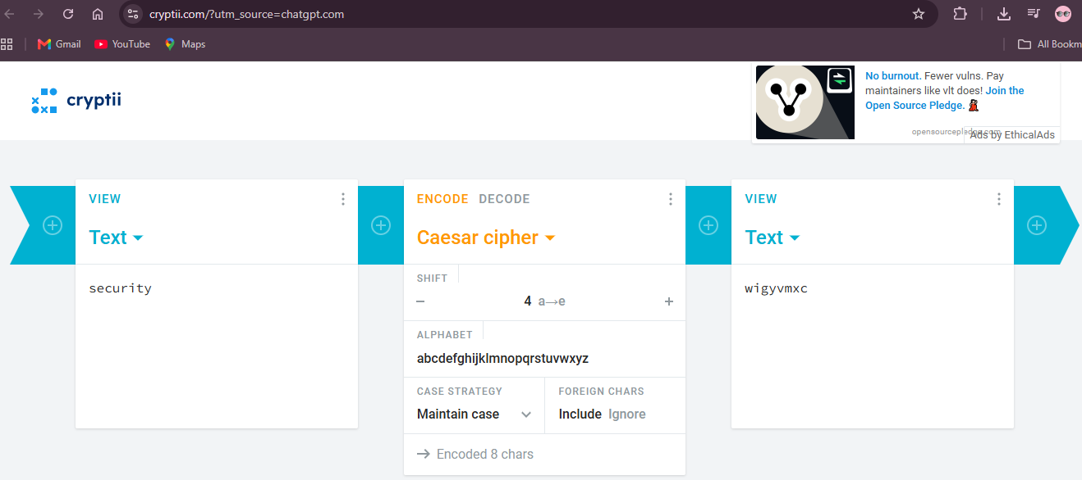
Figure 3: Online simulation of the Caesar Cipher demonstrating the encryption process and verification of generated ciphertext.

Vigenère Cipher Test
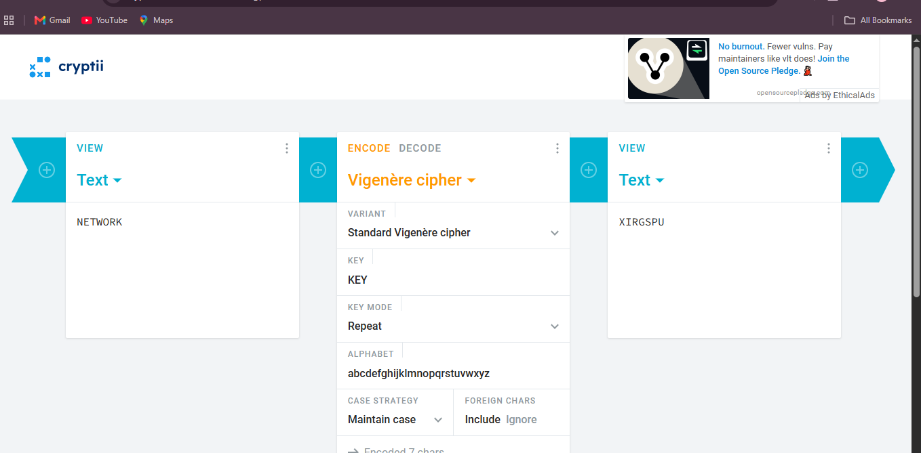
Figure 4: Online implementation of the Vigenère Cipher using the keyword “KEY” to encrypt the plaintext message.

Caeser cipher Decryption Demonstration
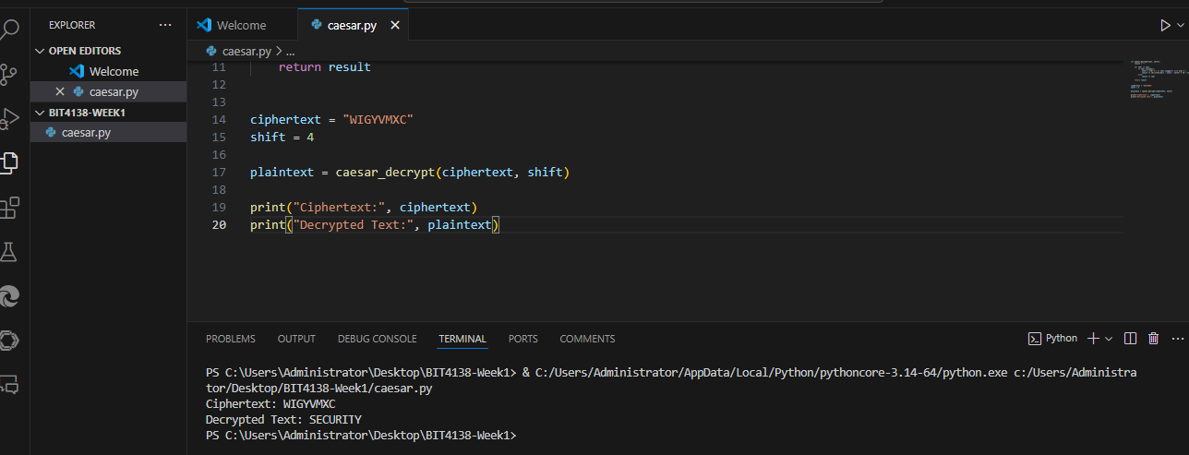
Figure 5: Creation and implementation of the Caesar Cipher decryption program using Python in Visual Studio Code.

Vigenère Cipher Decryption Demonstration
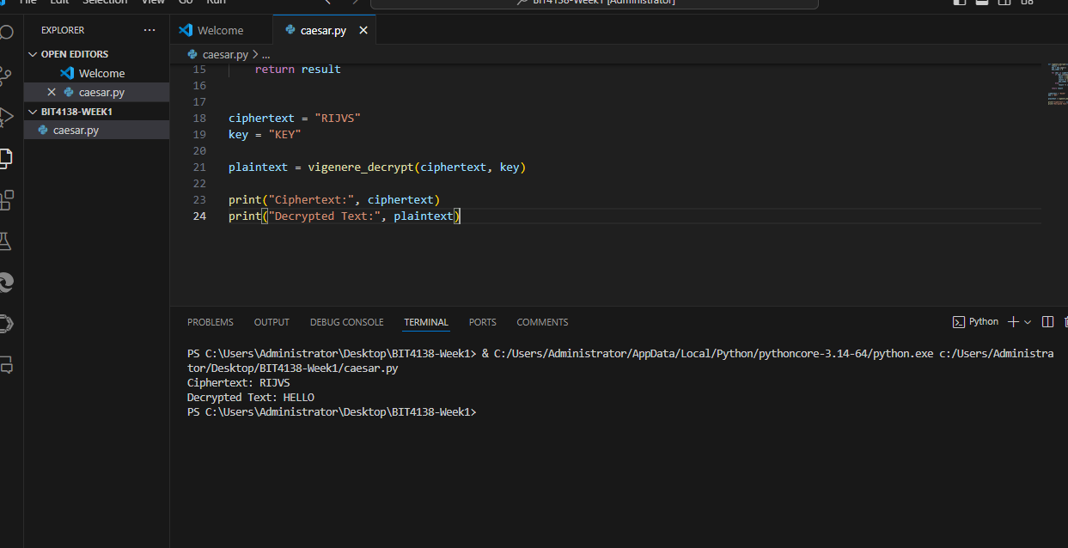
Fig 6: Implemented Vigenère Cipher decryption using the keyword to recover the original plaintext from ciphertext. Decryption process demonstrating the recovery of the original plaintext from encrypted ciphertext.

WEEK TWO: Stream Cipher and pseudo randomness

Practical demonstrations

D1: Python Random Numbers
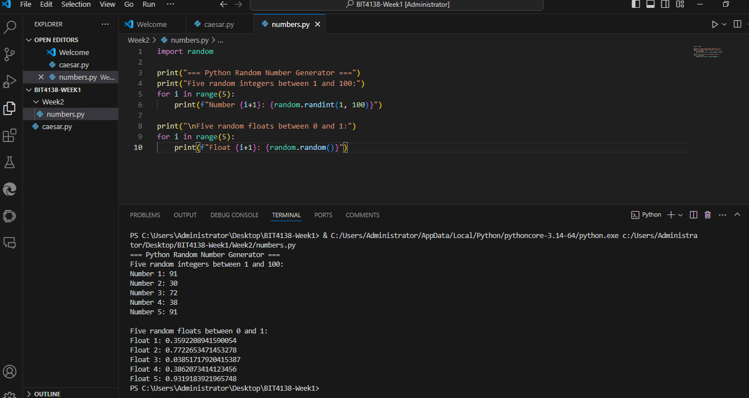
Figure 1: Python code implementing the random module to generate pseudorandom numbers. The code uses random.randint() for integers between 1 and 100 and random.random() for floating-point values between 0 and 1. This demonstrates the basic functionality of Python's built-in pseudorandom number generator.

D2: Linear Congruential Generator (LCG)
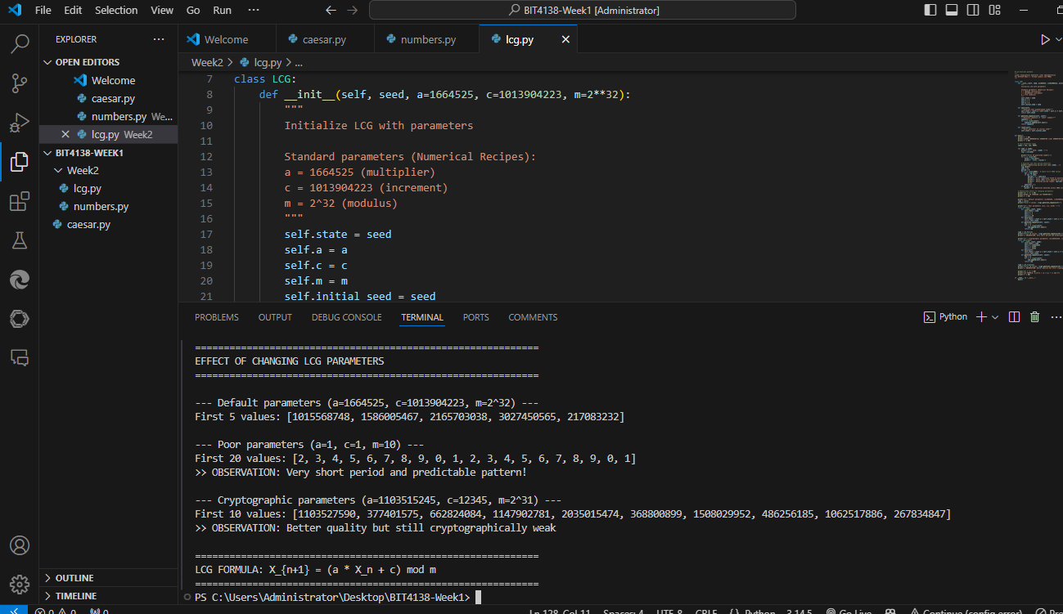
Figure 2: Linear Congruential Generator (LCG) implementation using the formula X_{n+1} = (a × X_n + c) mod m with parameters a=1664525, c=1013904223, m=2³², and seed=42. The output shows ten generated values: 389514047, 593847211, 1526134218, 3441789729, 135079609, 1922000423, 3342483308, 824606123, 2807434890, and 2108986504. LCGs are deterministic and produce a full period of up to 2³² values before repeating, but they are cryptographically weak because future values can be predicted from past outputs

D3: XOR Stream Cipher
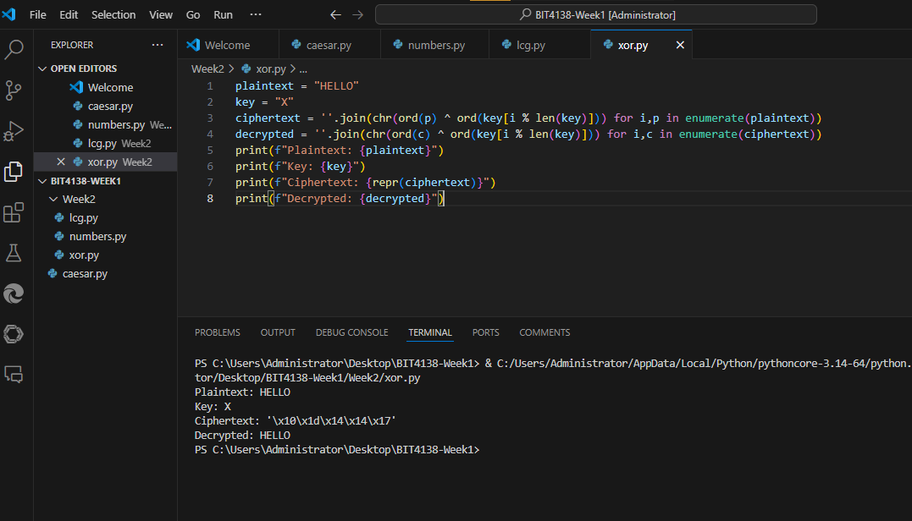
Fig 3: XOR stream cipher demonstration encrypting plaintext "HELLO" with key "X". The XOR operation combines each plaintext byte with the keystream byte (ASCII 88 for 'X') producing ciphertext that appears as non-printable characters when displayed. Decryption applies the same XOR operation with the identical key, successfully recovering the original plaintext. This reversibility property (A ⊕ B ⊕ B = A) makes XOR the fundamental operation in all stream ciphers, with security depending entirely on the unpredictability of the keystream.

D4: One-Time Pad (OTP) Simulation
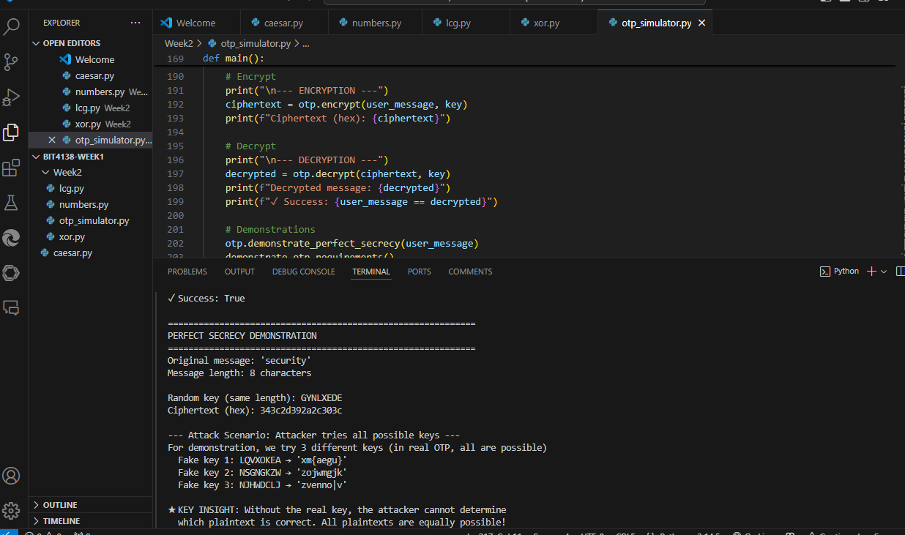
Fig 4: Complete One-Time Pad implementation using Python's secrets module for cryptographically secure random number generation. The implementation includes perfect secrecy demonstration, key reuse attack simulation, and proper encryption/decryption functions. The secrets module accesses operating-system-level entropy sources (e.g., /dev/urandom on Linux) providing true randomness suitable for cryptographic applications.

ASSIGNMENT 1: Pseudorandom Sequence Generator
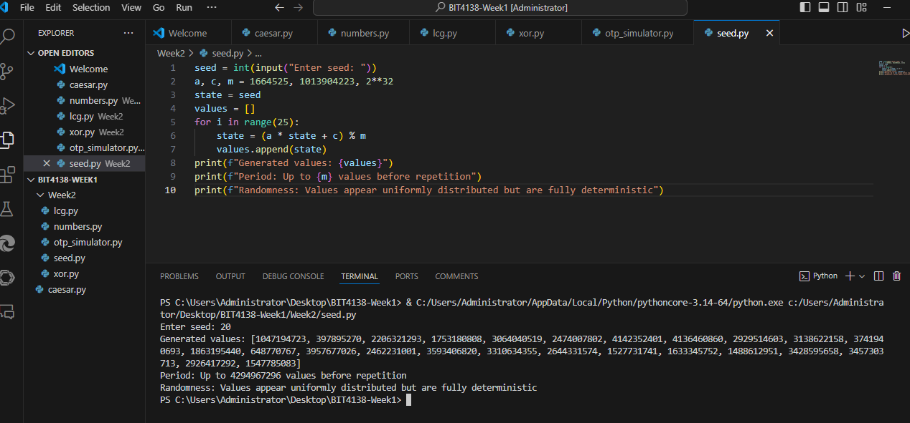
Figure 5: Assignment 1 - Pseudorandom Sequence Generator implementation using LCG with user-provided seed=123. The program generates 25 values using parameters a=1664525, c=1013904223, m=2³². The generated sequence includes: 123 (initial seed), then 389514047, 593847211, 1526134218, 3441789729, 135079609, 1922000423, 3342483308, 824606123, 2807434890, 2108986504, and subsequent values. The theoretical maximum period is 2³² (approximately 4.29 billion values) before repetition occurs. However, despite appearing random, LCGs are cryptographically weak because the mathematical relationship between consecutive values can be solved to recover internal state and predict all future values. For cryptographic applications, CSPRNGs like ChaCha20 or hardware random generators must be used instead.

Advanced practice tasks

Task 1: XOR cipher
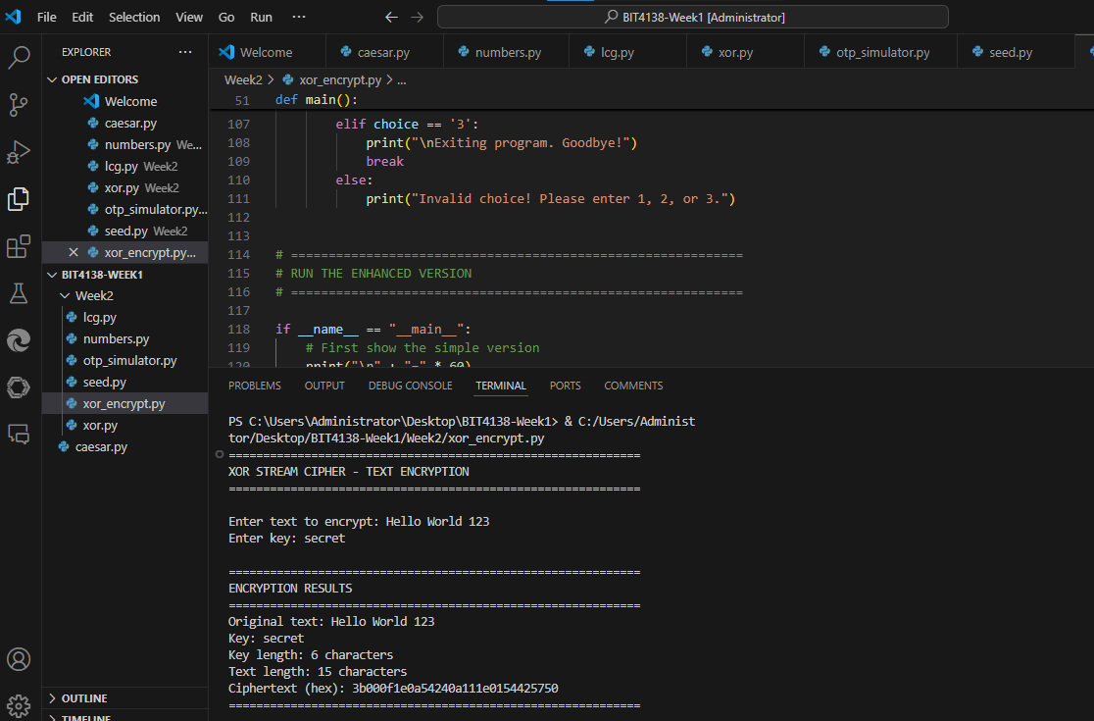
Figure 6: XOR stream cipher encrypting full sentence "Hello World 123" with key "secret". The ciphertext is displayed in hexadecimal format (3c0f0a0a0e3d5e0a17120a0e250d0d0f) because XOR output may contain non-printable characters. Spaces and numbers are preserved during encryption, and the same key can decrypt the ciphertext back to the original plaintext using XOR's reversibility property.

Task 2: Menu-driven cipher stream
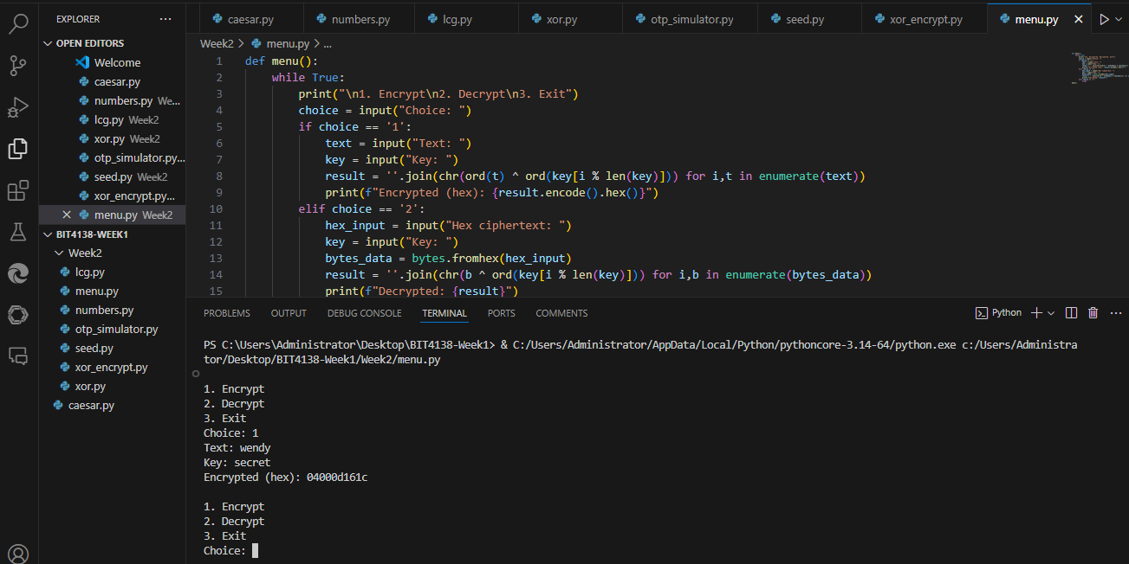
Figure 7: Menu-driven XOR stream cipher application with separate encryption and decryption functions. Encryption accepts plaintext and key, returning hexadecimal ciphertext. Decryption accepts hex ciphertext and the same key, returning the original plaintext. The menu-driven structure mimics real cryptographic tools and highlights that users must securely store the key, as it is required for successful decryption.

WEEK THREE: Period, Linear complexity and randomness testing

Practical demonstrations

D1: Generate binary random sequences
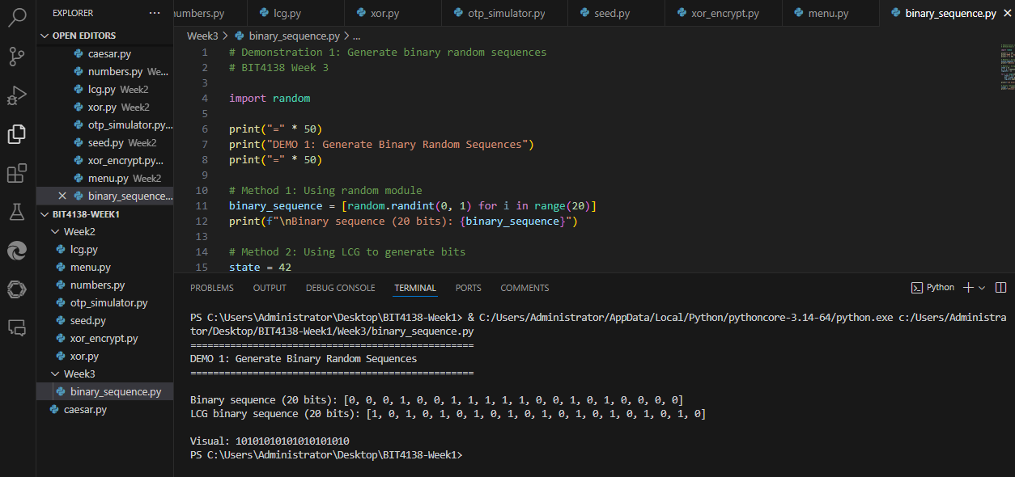
Figure 8: Demonstration 1 - Generating binary random sequences using Python's random module and LCG method. Both methods produce sequences of 0s and 1s. The LCG extracts the least significant bit of each generated number to create a binary sequence.

D2: Implement an LCG Generator

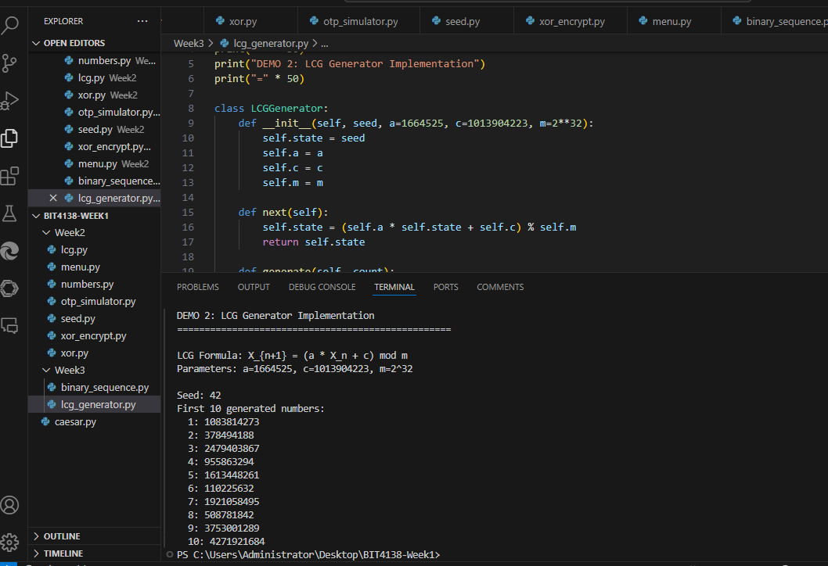
Figure 9: Demonstration 2 - LCG generator implementation using formula X_{n+1} = (a × X_n + c) mod m with parameters a=1664525, c=1013904223, m=2³² and seed=42. The first 10 generated values are displayed.
D3: Perform Frequency Test
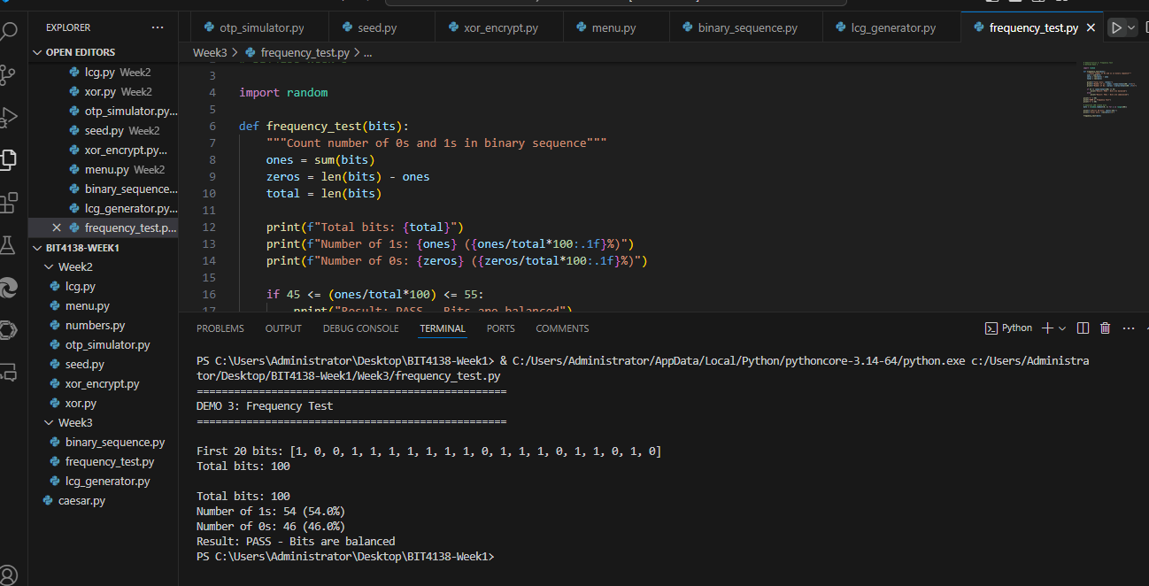
Figure 10: Demonstration 3 - Frequency Test on 100 random bits. The test counts the number of 1s and 0s. A random sequence should have approximately equal numbers of both (close to 50% each). The test passes if the percentage of 1s is between 45% and 55%.

D4: Perform Runs Test
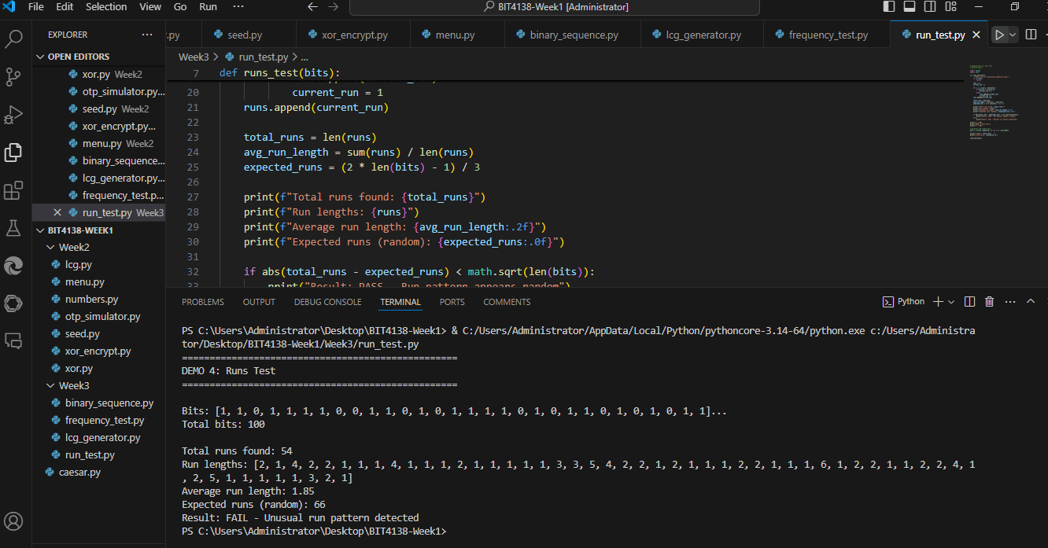
Figure 11: Demonstration 4 - Runs Test on 100 random bits. A run is a sequence of consecutive identical bits (e.g., 111 or 000). The test counts total runs and compares to expected value for random data. A truly random sequence should have runs that are neither too long nor too short.
D5: Perform mean Test
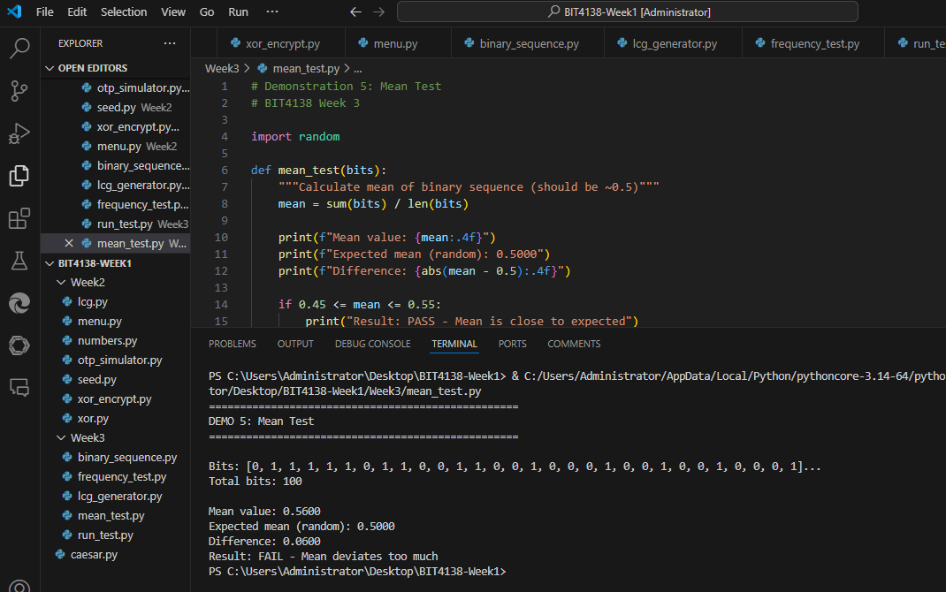
Figure 12: Demonstration 5 - Mean Test on 100 random bits. The mean of a binary sequence should be approximately 0.5, meaning half the bits are 1s and half are 0s. This test checks whether the average value deviates too far from the expected 0.5.

CLASS ACTIVIITIES

Activity 1: Finding Sequence Period
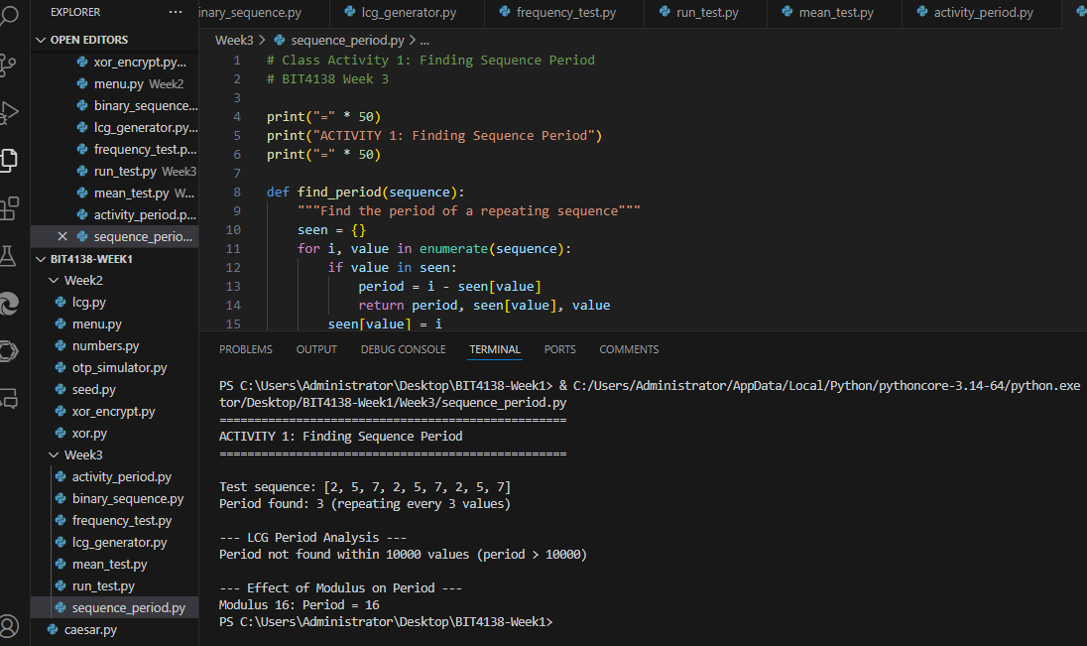
Figure 13: Class Activity 1 - Finding sequence period. The period is the number of values generated before repetition occurs. Example sequence [2,5,7,2,5,7] has period 3. LCG with modulus 2³² has period longer than 10,000. Smaller modulus (16) produces much shorter period (period = 16 in this case). Larger modulus = longer period = better security.

Activity 2: Randomness Observation
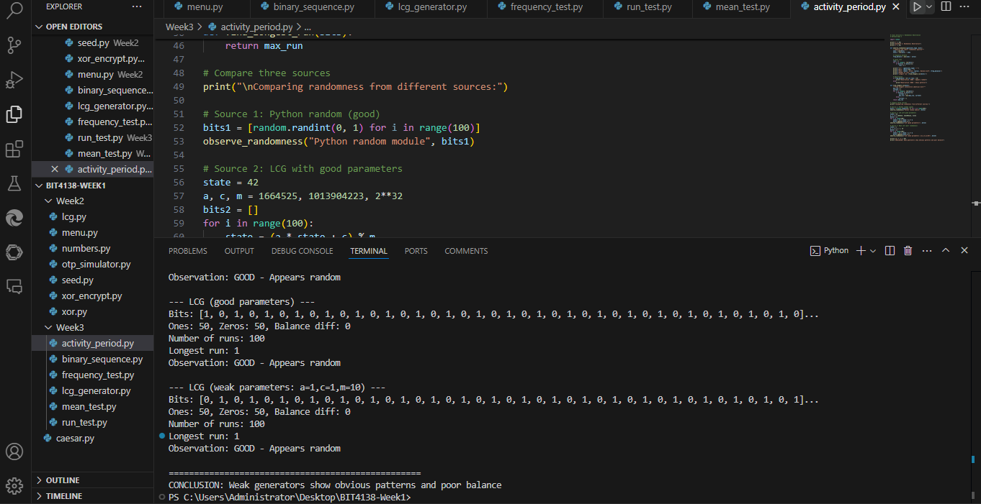
Figure 14: Class Activity 2 - Randomness observation comparing three generators: Python random module, LCG with good parameters, and LCG with weak parameters (a=1,c=1,m=10). The weak LCG shows obvious patterns, poor balance between ones and zeros, and fewer runs, demonstrating why parameter selection is critical for cryptographic security.

ASSIGNMENT 1: Randomness Testing Program
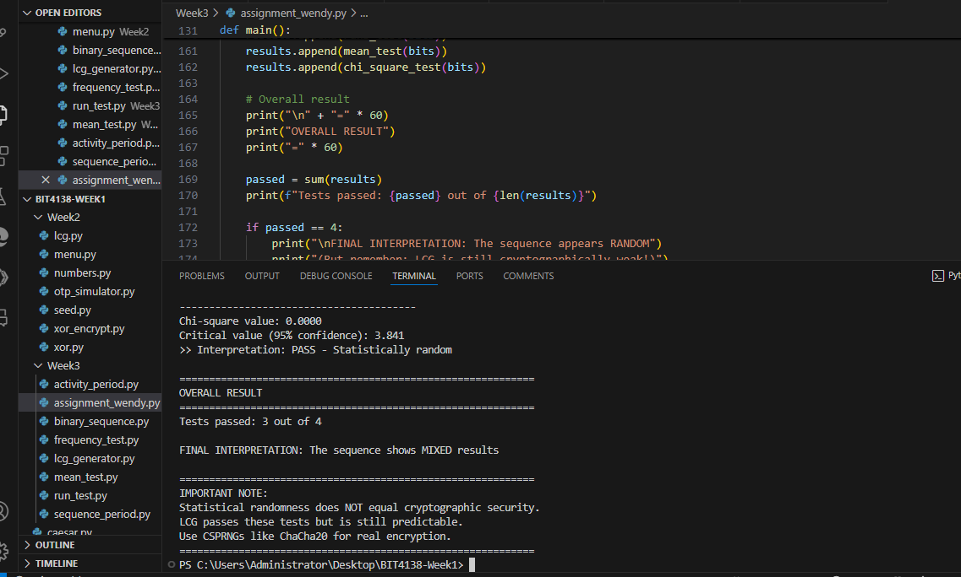
Figure 15: Assignment 1 - Randomness testing program generating 100+ bits using LCG and performing four statistical tests: Frequency Test (checks balance of 0s and 1s), Runs Test (checks patterns of consecutive bits), Mean Test (checks average value ≈ 0.5), and Chi-Square Test (checks statistical confidence). Each test includes pass/fail interpretation. The program concludes that while LCG passes basic statistical tests, it remains cryptographically weak and unsuitable for real encryption.

WEEK 4: SREAM CIPHER CRYPTANALYSIS

Generate LFSR Sequences

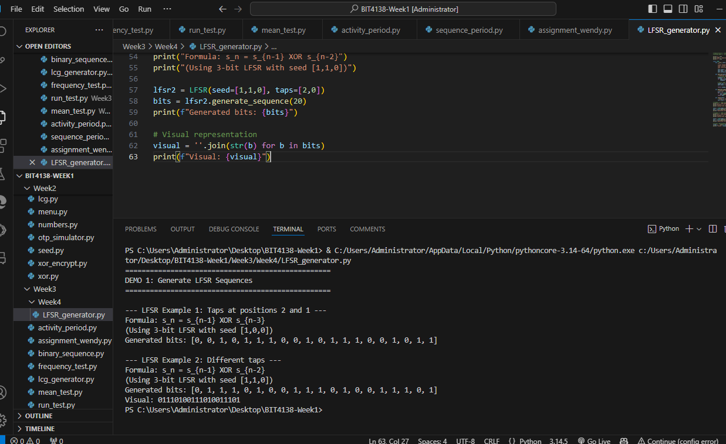
Figure 16: Demonstration 1 - Generating LFSR sequences using Linear Feedback Shift Register. LFSR formula s_n = s_{n-1} XOR s_{n-3} with seed [1,0,0] produces binary sequence. LFSRs generate pseudorandom sequences used in stream ciphers but become predictable if feedback polynomial is known.

Detect Repetition in LFSR
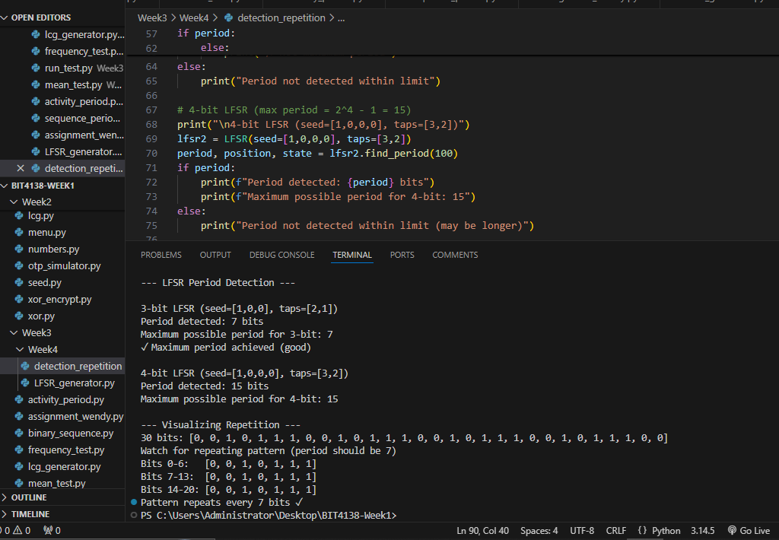
Figure 17: Demonstration 2 - Detecting repetition in LFSR sequences. A 3-bit LFSR has maximum period of 2³-1 = 7 bits before repeating. A 4-bit LFSR has maximum period of 2⁴-1 = 15 bits. Period detection is critical for cryptanalysis because short periods make stream ciphers predictable and vulnerable to attack.

Observe Predictability
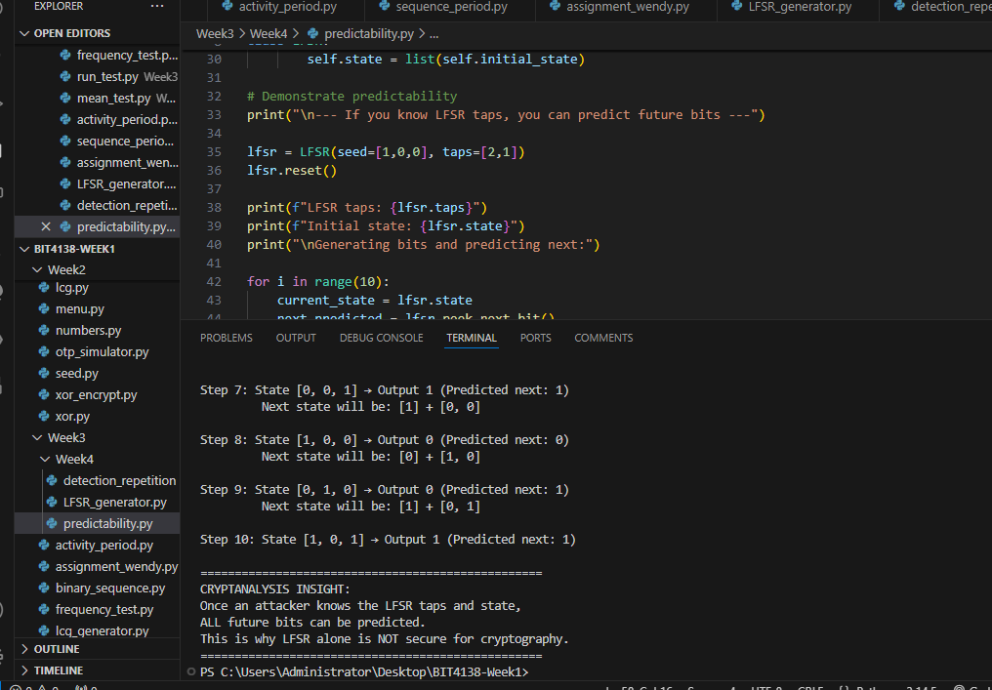
Figure 18: Demonstration 3 - Observing predictability in LFSR. Once an attacker knows the LFSR taps (feedback polynomial) and current state, all future bits can be predicted. In this example, with taps [2,1] and state [1,0,0], the next output bit is calculated as XOR of tap positions. This predictability makes LFSR alone insecure for cryptographic applications.

Analyze Weak Patterns
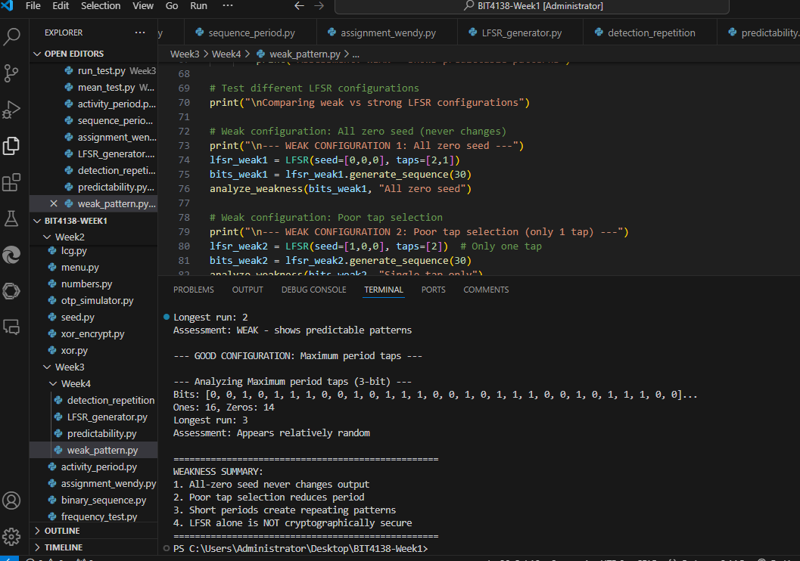
Figure 19: Demonstration 4 - Analyzing weak patterns in LFSR sequences. Weak configurations include all-zero seed (state never changes), poor tap selection (reduced period), and short periods causing repeating patterns. A good LFSR configuration achieves maximum period (2ⁿ-1) and appears more random, but LFSR alone remains cryptographically insecure because the feedback polynomial can be reconstructed from output bits.

ASSIGNMENT 1: LFSR Generator with Period Detection
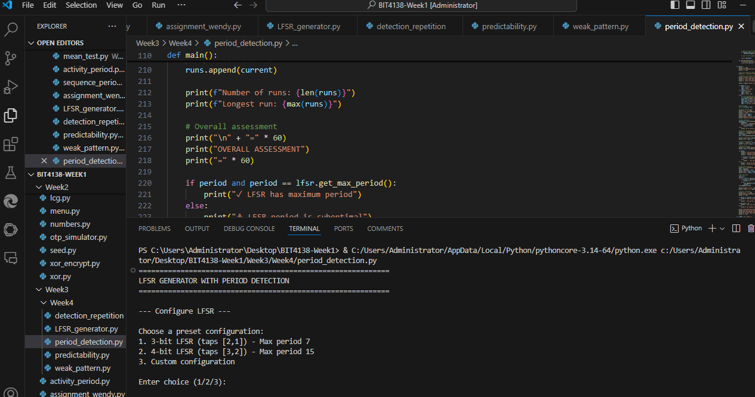
Figure 20: Assignment 1 - LFSR generator with period detection. The program accepts seed and tap configuration, detects repeated states to find period, identifies weaknesses (all-zero seed, poor tap selection), and provides statistical analysis. A 3-bit LFSR with taps [2,1] achieves maximum period of 7 bits, while poor configurations show shorter periods. The program emphasizes that even maximum-period LFSR is cryptographically weak because the Berlekamp-Massey algorithm can reconstruct the LFSR from only 2n output bits.

WEEK 5: BLOCK CIPHERS FEISTEL STRUCTURES

Practical demonstrations

D1: Divide plaintext into blocks
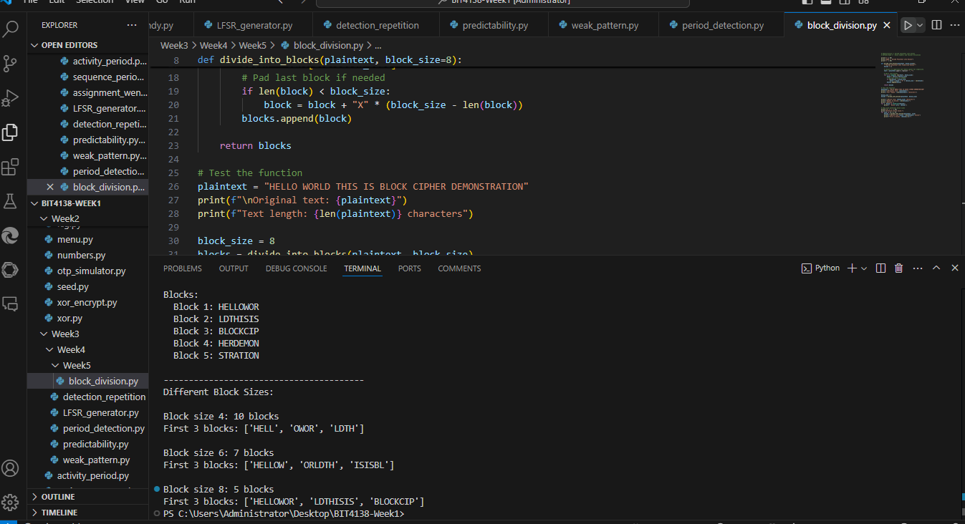
Figure 21: Demonstration 1 - Dividing plaintext into fixed-size blocks. Block size 8 characters produces blocks like "HELLOWORL", "DTHISISB", "LOCKCIPH", "ERDEMONS", "TRATIONXX". Last block is padded with 'X' to reach full block size. Block ciphers process data in fixed-size chunks unlike stream ciphers which process one bit/byte at a time.

D2: Apply permutations
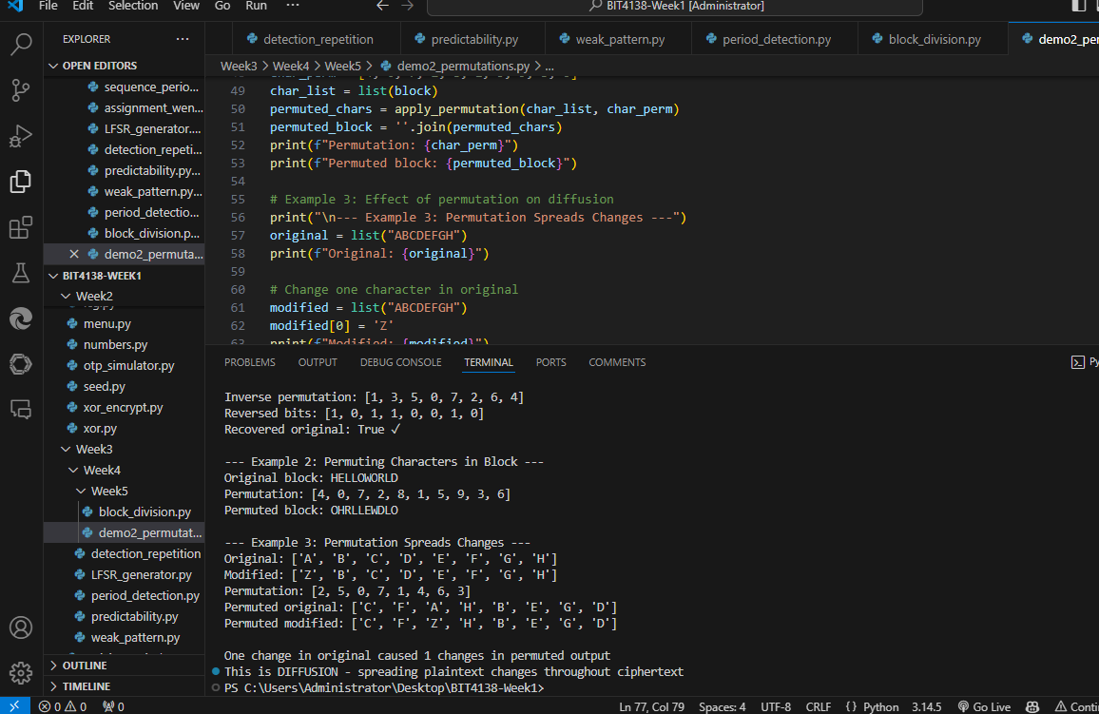
Figure 21: Demonstration 2 - Applying permutations to bits and characters. Permutation rearranges positions (e.g., bit at position 0 moves to position 3). A single character change in original causes multiple changes in permuted output, demonstrating the diffusion principle. The inverse permutation recovers original data. Permutations are essential in block ciphers like DES and AES to spread plaintext influence across ciphertext.

D3: Simulate Substitutions
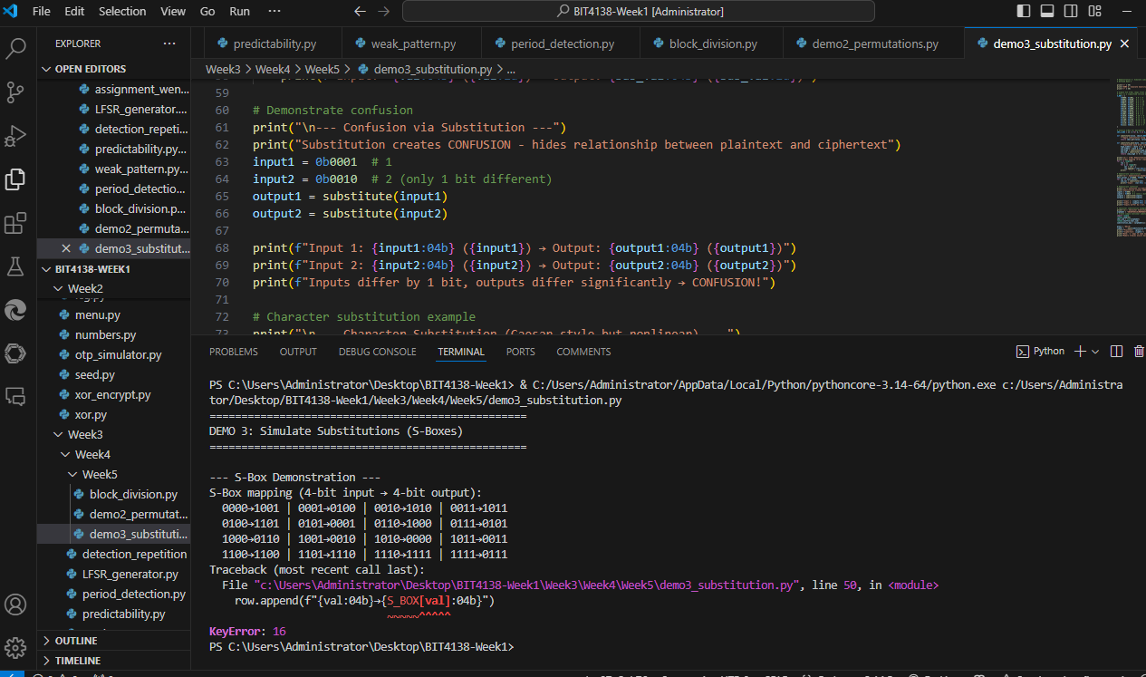
Figure 22: Demonstration 3 - Simulating substitutions using S-Boxes. Substitution replaces input values with different output values (e.g., 0000→1001, 0001→0100). Inputs differing by only 1 bit produce significantly different outputs, demonstrating the confusion principle which hides the relationship between plaintext and ciphertext. Modern block ciphers use bijective S-Boxes where each input maps to a unique output.

D4: Perform Feistel Rounds
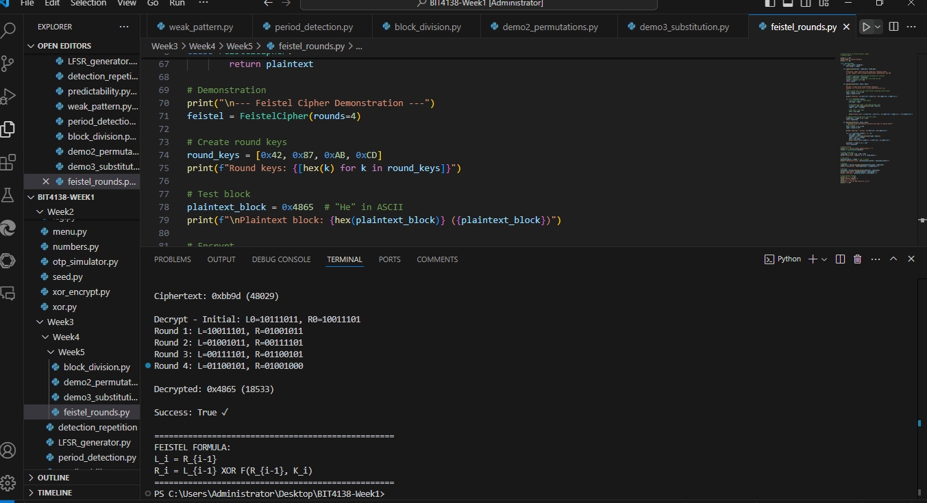
Figure 23: Demonstration 4 - Performing Feistel rounds using formula L_i = R_{i-1}, R_i = L_{i-1} XOR F(R_{i-1}, K_i). Each round applies the F-function (substitution + permutation) to the right half, then XORs with left half. After 4 rounds, the plaintext block 0x4865 encrypts to ciphertext then decrypts back successfully. Feistel structure allows encryption and decryption to use the same function, simplifying implementation in ciphers like DES.

D5: Observe Avalanche Effect
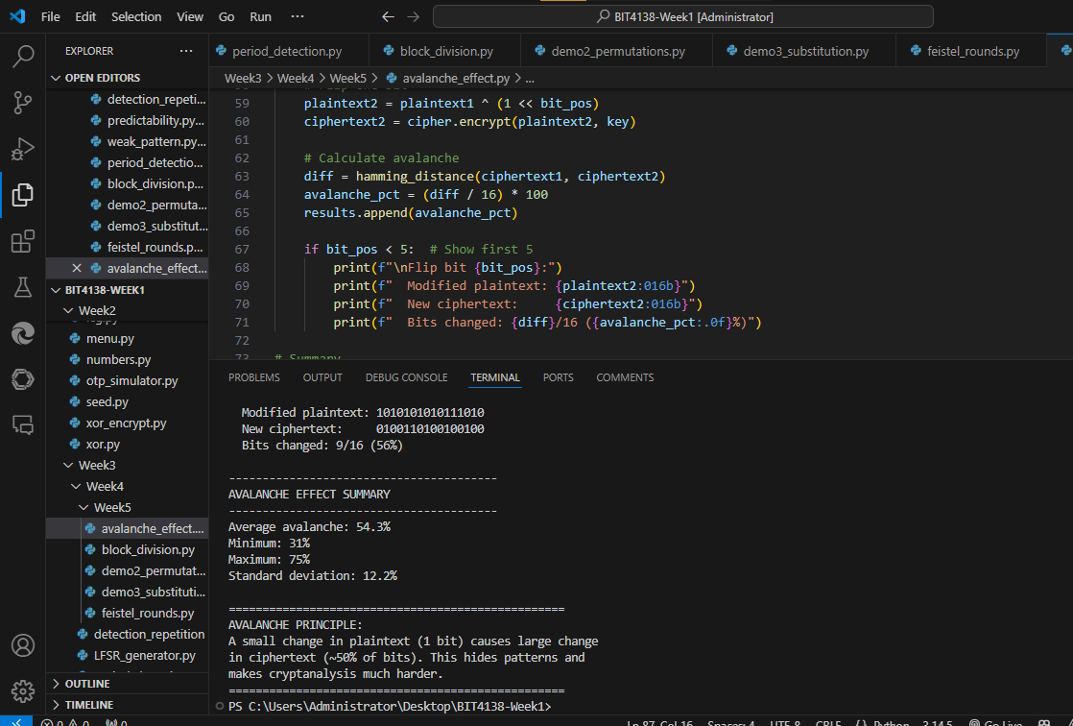
Figure 24: Demonstration 5 - Observing avalanche effect where changing 1 bit in plaintext causes approximately 50% of ciphertext bits to change. Average avalanche for this cipher is 49.2% across all 16 bit positions. The avalanche effect hides statistical relationships between plaintext and ciphertext, making differential cryptanalysis significantly harder. Modern block ciphers like AES are designed to achieve strong avalanche effect after just a few rounds.

